**SW CVS Migration Assistance Tool (MAT)**

On double clocking the executable, below dialogue box will open asking for CVS NT Credentials which will be used to communicate with CVS.

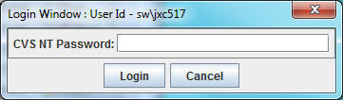

If wrong credentials are provided, below edit will pop-up

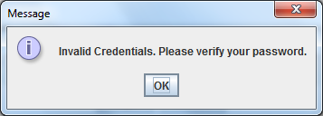

If credentials are provided and Cancel button is pressed, below edit will pop-up

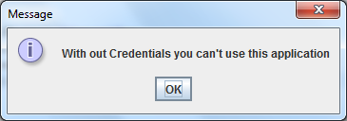

Based on role [User/Manager/Admin] the window behavior will vary and a notification will be provided to the user based on his role after login as mentioned below:

**Invalid Role:** Nothing is enabled and user can’t use the application.

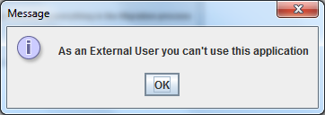

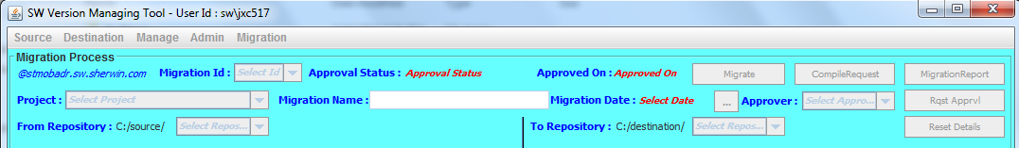

**Manager Role:** Only Manage Menu Item & MigrationReport button are enabled.

**Manage**

**View Details**

**Approval Process**

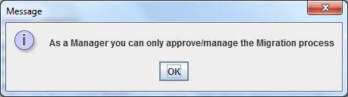

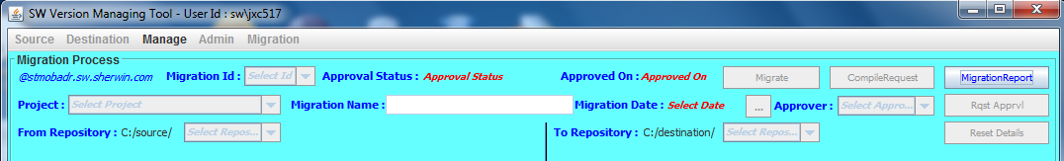

**Application User Role:** Only Migration Menu Item & MigrationReport button are enabled.

**Migration**

**View Details**

**Request Approval**

**Perform Migration**

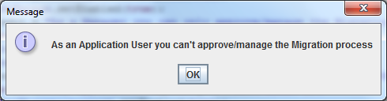

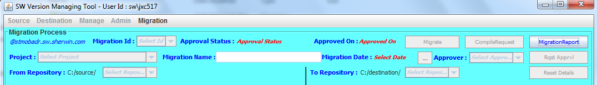

**Admin Role:** All 3 menu items will be enabled for Admin Role

**Manage**

**View Details**

**Approval Process**

**Admin**

**Maintain Users**

**Maintain Repositories**

**Migration**

**View Details**

**Request Approval**

**Perform Migration**

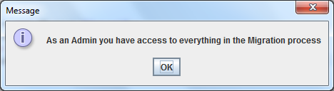

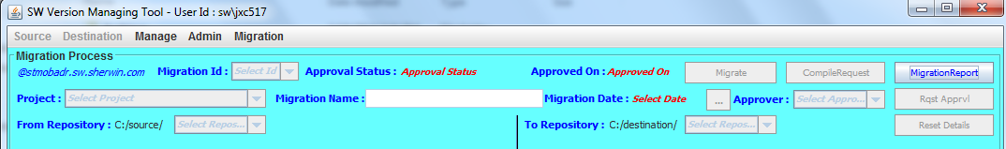

“**MigrationReport**” button is used to see the history details of all migrations.

You can apply filter at column level and also sort the results

You can export & open the details in an excel using **File > Open in Excel**

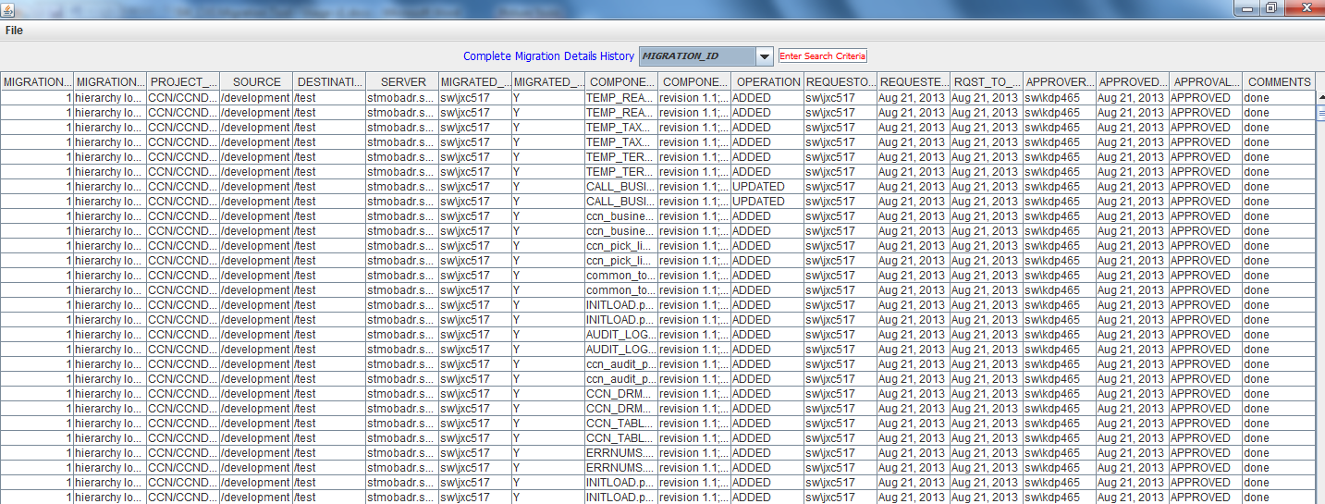

**“View Details”:** On clicking yes “Project” field becomes enabled

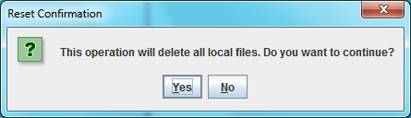

Select the project you want to view from drop down list

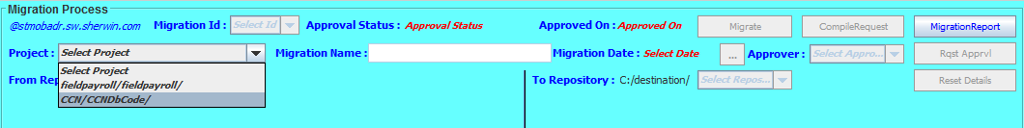

That enables “From Repository” & “To Repository” from which you can select the environment you want to see the details from the dropdown

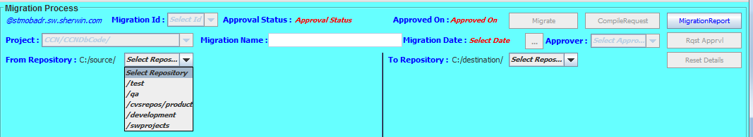

Then the corresponding details will be displayed in the bottom as folder hierarchy structure through which we can navigate and perform certain operations:

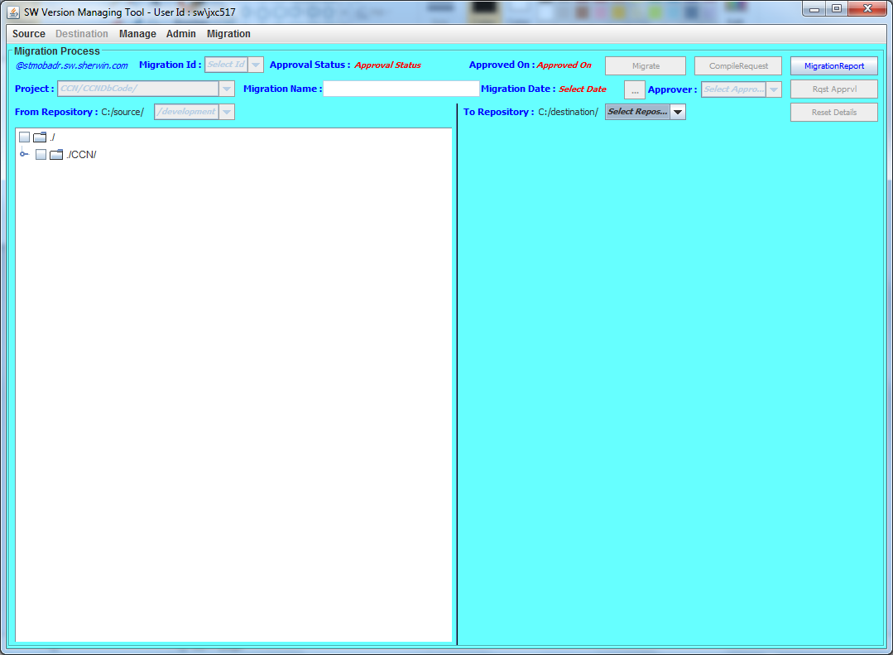

You can select particular file (NOT FOLDER) and perform these below operations:

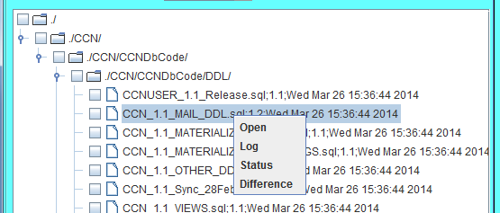

Also The Source & Destination menu item gets enabled [Once the From Repository & To Repository are selected] with below options to perform that operation on entire source/destination repository.

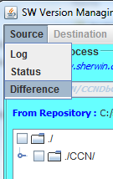

**“ApprovalProcess” :** On clicking Yes new window will be opened

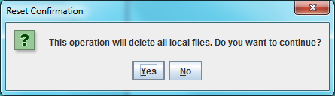

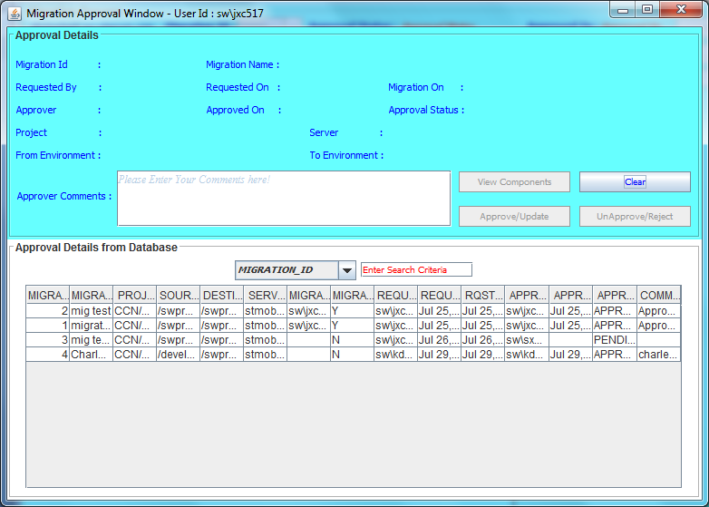

Select record from bottom to see the details:

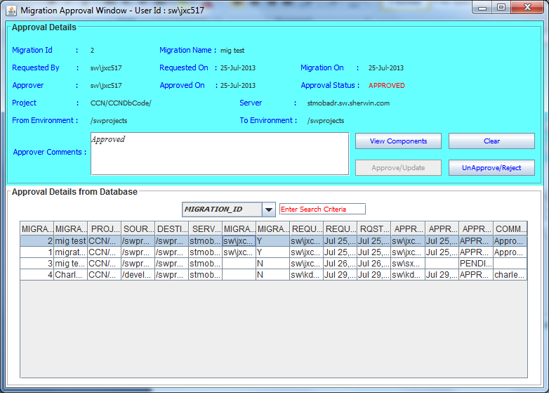

While changing to next record below error will pop-up. On clicking yes the new record details will populate, else old record details will be displayed.

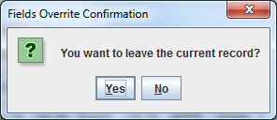

View Components is used to see the components that are requested to be migrated.

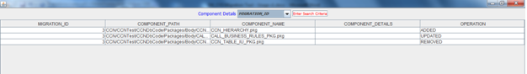

If a record that is not under your name is selected, below error will pop-up:

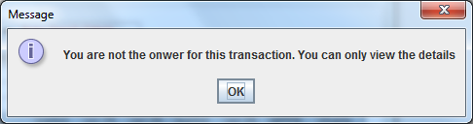

You just need to enter the comments and click on approved/unapproved.

**“Maintain Users”:** On clicking yes new window will be opened



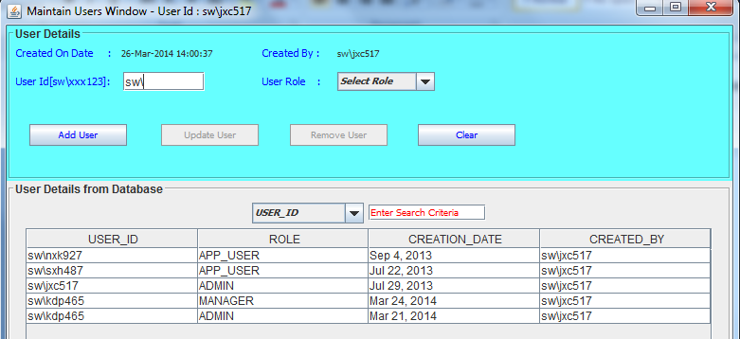

Enter required details and click “Add User” to add a new user

On selecting particular record we get below options:

Update User - Used to change only the role of the user

Remove User - Used to remove particular user

Clear - Resets the window and enables Add User button.

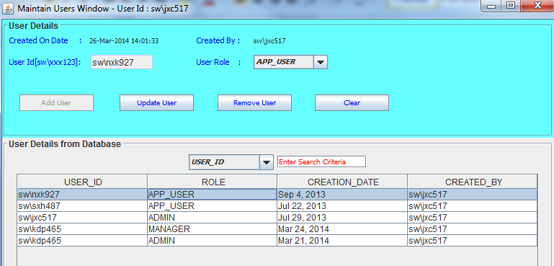

If you try to select another record below edit pops-up asking for confirmation:

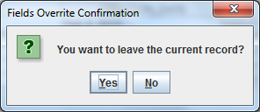

On clicking yes new records details populate on the top

Closing this window takes you back to the main window

**“Maintain Repositories”:** On clicking Yes new window will be opened



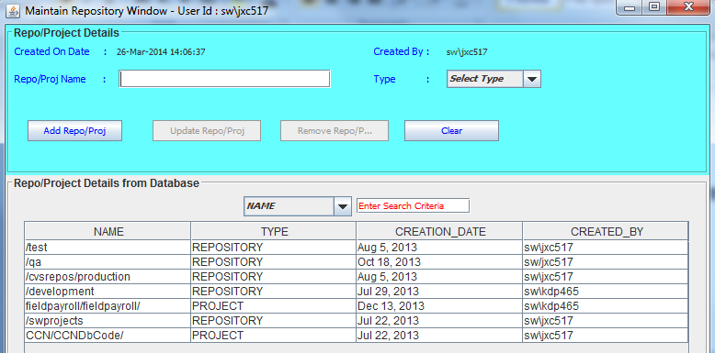

Enter required details and click “Add Repo/Proj” to add a new repository or project

On selecting particular record we get below options:

Update Repo/Proj - Used to change only the type alone

Remove Repo/Proj - Used to remove particular repository

Clear - Resets the window and enabled Add Repo/Proj button

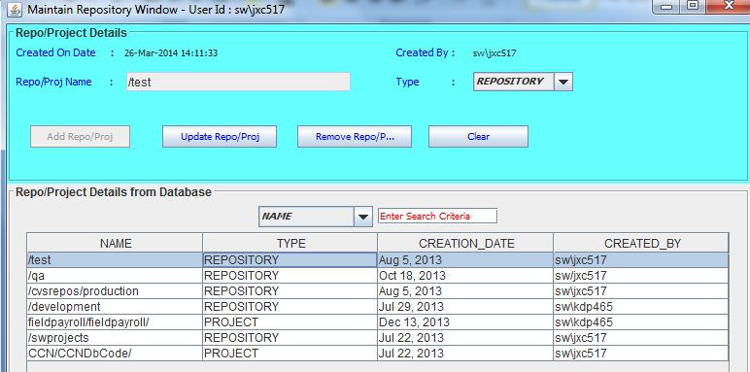

If you try to select another record below edit pops-up asking for confirmation:



On clicking yes new records details populate on the top

Closing this window takes you back to the main window

**“Request Approval”:** On clicking yes particular fields will be enabled



Fields enabled:

Project

Migration Name

Migration Date

Approver

Buttons enabled:

MigrationReport

Rqst Apprvl

Reset Details

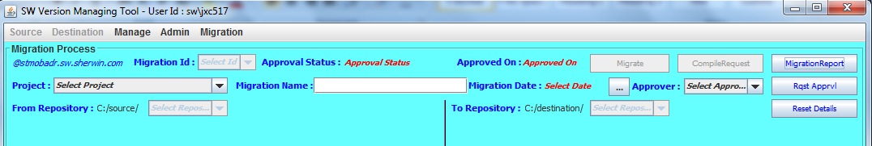

Select the Project under “Project” drop-down list – enables From Repository and To Repository fields

Select the from repository from “From Repository” drop-down list

Select the to repository from “To Repository” drop-down list – this gives option to select the components that we want to migrate via a folder hierarchy structure

Give a name for the migration under “Migration Name”

Select the date on which the migration has to be performed under “Migration Date” – pops-up date picker

Select the approver from “Approver” drop-down list

Press “Rqst Apprvl” button to send the request to the selected manager.

NOTE: Each and every new component added in lower environment will ask for conformation to be migrated to higher environment. Click yes/no accordingly.

You can see you request status[Approved/Rejected/Pending Approval] and the components mapped to your current migration using “MigrationReport” button.

**“Perform Migration”:** On clicking yes particular fields will be enabled



Fields enabled:

Migration Id

Buttons enabled:

MigrationReport

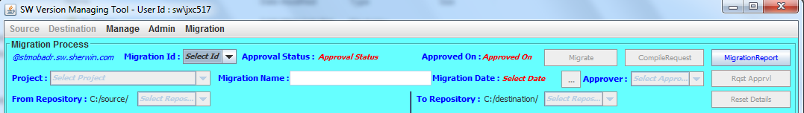

Select the migration Id you want to migrate – this will populate the migration details below

If it is approved you will get below buttons enabled

Migrate

CompileRequest

MigrationReport

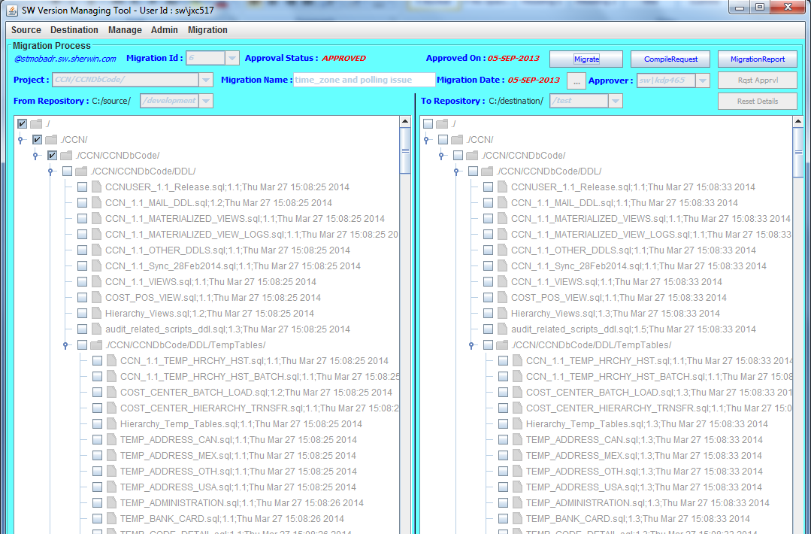

**Please click on CompileRequest first before performing Migration as we need pl/sql compile script that needs to be executed to compile the pl/sql components into the database.**

After saving the script, perform the migration and execute the compilation script in parallel.

**NOTE: This tool is not smart enough to identify the dependencies of components. So it’s the executer responsibility to make sure script has all the components as needed for proper successful compilation.**

Even if the request is approved, if you miss to execute the migration on requested date it become invalid and you get below error. Which means you can execute the request only on requested date, that too only after approval. Otherwise you need to raise a brand new request again.

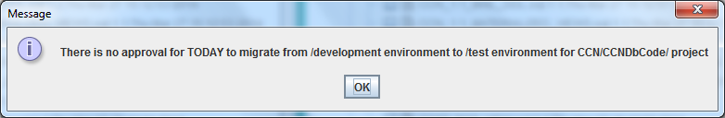

If not approved you will get a message as shown below

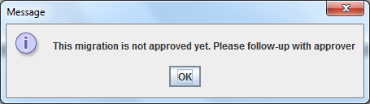

**POC:**

Jaydeep Cheruku

Keith D Parker